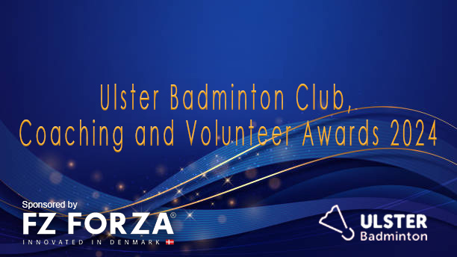

Supporting Information
The Ulster Badminton Coaching Awards sponsored by FORZA BADMINTON recognise the outstanding contribution of badminton clubs, coaches and volunteers and the role they play in encouraging participation, development and excellence.
There are 4 award categories, and this document provides further information on each of the award categories, together with key evidence the judging panel will look for when making decisions.

Awards Categories
The individual awards are for Clubs, coaches and volunteers who have shown outstanding commitment and / or achieved excellent results in a specific area or with a particular individual and / or group over the last 12 months.

Club of the Year
This award recognises the achievements of a club throughout 2023/24 season.
What we are looking for:
- Impact the club or sporting organisation has had on and the wider community.
- Dedication to the sport, growing participation, inclusivity or innovation.
- Evidence of innovation within the club.
- Examples of how the club has developed over the last 12 months.

Club Coach of the Year
This award recognises the outstanding contribution of a coach in a juvenile club setting focusing on the young people’s skill development, understanding, enjoyment, and lifestyle through sport.
What we are looking for:
- A coach working with young people under the age of 16.
- Evidence of the development of basic skills through fun in badminton.
- Evidence of appropriate player centred engagement and high quality coaching.
- Examples of innovative practice.

Young Coach of the Year
This award recognises the important work carried out by an up and coming coach through his or her coaching achievements or their commitment to date and the impact they have made on the people they coach.
What we are looking for:
- A coach who is 25 years of age or under at the date of nomination.
- Evidence of creativity and determination in their development as a coach.
- Evidence of the provision of opportunities and dedicated support for players to help them improve and reach their goals.
- Examples of innovative practice.

Talent Coach of the Year
This award recognises the achievements of a coach working to develop emerging and young talented performers from within badminton.
What we are looking for:
- Evidence of innovative practice.
- Evidence of player centred, high quality coaching that encourages the development of performance within sport and nurtures talent.
- Evidence that the coach has assisted the development of players by helping them achieve success and / or improve performances.

Volunteer of the Year
This award recognises the outstanding contribution of a club volunteer and the impact that they have made within their club across the year and the impact that they have had within their club.
What we are looking for:
- Length of service as a volunteer (minimum 1 year).
- Number of roles served within the club or sporting organisation.
- Impact on the club or sporting organisation and the wider impact on the community.
- Dedication to the sport, growing participation, inclusivity or innovation.

Award Prizes
Each award winner will receive a generous award pack from our sponsors Forza as well as a trophy marking their outstanding achievement.

Ulster Badminton Coaching Awards 2023 Nomination Form
Deadline: Friday 29th March 2024
Award Category
Please indicate which category or categories you are nominating this candidate for:
(If you wish to enter the candidate for more than 1 category, please tick multiple boxes).
Club of the Year
Club Coach of the Year
Young Coach of the Year
Talent Coach of the Year
Volunteer of the Year

Nominator:
Name
Address

Postcode
Email Address
Telephone Number
Relationship to Nominee

Nominee:
Name/ Club
Address

Postcode
Email Address
Telephone Number
Date of Birth
Current Position
Coaching Qualification / Level
Number of Years Coaching/ Volunteering
Levels of Players Coached
(club/regional/provincial//national)

Please provide a statement in the boxes below to endorse your nomination, you may wish to explain how the club, coaching or volunteering has made an impact: Impact/ Qualities. Knowledge, Skills and Experience
Impact/ Qualities:

Knowledge:

Skills:

Experience:

Any other information:

Nomination forms should be returned via email or post by latest Friday 29th March 2024 to:
Email: developmentofficer@ulsterbadminton.com
Address: Ulster Badminton. National Badminton Centre. 36 Belfast Road, Lisburn, BT27 4AS

